Lancashire Wellbeing Service
Consultation report – 2019

Mick Edwardson, Mike Walker, Melissa Sherliker,
Marie Demaine, Gavin Turnbull, and Stephanie Windross

April 2019

For further information on the work of Business Intelligence please contact us at
Business Intelligence
Lancashire County Council
County Hall
Preston
PR1 8XJ
Tel: 0808 1443536
www.lancashire.gov.uk/lancashire-insight

Contents

1. Executive summary 3

1.1 Key findings 3

2. Introduction 6

3. Methodology 7

3.1 Limitations 8

4. Main findings – public 9

4.1 Use of the Lancashire Wellbeing Service 9

4.2 The proposal for the Lancashire Wellbeing Service 11

5. Main findings – partner organisations 14

5.1 The proposal for the Lancashire Wellbeing Service 14

6. Main findings - consultation workshops 18

6.1 Key Themes 18

6.2 Impact of the proposal 18

6.3 The proposal for the Lancashire Wellbeing Service 24

7. Other responses 26

7.1 Petition 26

7.2 Letters and emails from service users/general public 26

7.3 Responses from MPs 26

7.4 Responses from organisations 26

7.5 Response from the Police and Crime Commissioner for Lancashire 27

Appendix 1 - Demographic breakdown - public 28

Appendix 2 – other responses 31

1.1 Petition - Save Lancashire Wellbeing Service! 31

1.2 Letters and emails from service users/general public 31

1.3 Responses from MPs 40

1.4 Responses from organisations 46

1.5 Response from the Police and Crime Commissioner for Lancashire 60

Executive summary
This report summarises the response to Lancashire County Council's consultation on the Lancashire Wellbeing Service (LWS).

The fieldwork ran for eight weeks between 28 January 2019 and 25 March 2019. In total, 1,196 completed questionnaires were returned for the service users/general public consultation (11 paper questionnaire responses and 1,185 online questionnaire responses). For the organisation consultation 119 completed questionnaires were returned.

Consultation workshops with service users, service providers and partner organisations were held between 4 March and 22 March 2019. In total, 89 people attended the workshops (56 service users and 33 service providers/partner organisations).

During the consultation period we received the petition 'Save Lancashire Wellbeing Service!' which as of 25 March 2019 had received 4,230 signatures. We also received three emails/letters from service users and one from an employee of an organisation affected by the proposal, four email/letters from MPs, seven written responses from organisations and a response from the Police and Crime Commissioner for Lancashire.

Key findings
    - Finding from service users and general public consultation
      - Use of the Lancashire Wellbeing Service (LWS)
- About half of respondents (51%) said that they have used the Lancashire Wellbeing Service in the past two years. Just less than half of respondents (45%) said that they had not used the Lancashire Wellbeing Service in the last two years.
- Of those respondents who have used the Lancashire Wellbeing Service in the last two years, about half (49%) said that they had used it for themselves and about two-fifths (43%) said that they had used it for someone else (who isn't a family member, friend or neighbour).
- Of those respondents who have used the Lancashire Wellbeing Service in the last two years, the most common reasons stated for using the service were mild mental health problems (77%), social isolation (57%), family support (40%) and healthy lifestyle support (39%).
- Of those respondents who have used the Lancashire Wellbeing Service in the last two years, nearly all said that the support they received had been helpful (88% very helpful and 8% fairly helpful).

      - The proposal for the Lancashire Wellbeing Service
- Over four-fifths of respondents (84%) strongly disagree with the proposal to cease the Lancashire Wellbeing Service. One in twenty respondents (5%) strongly agree with the proposal to cease the Lancashire Wellbeing Service.
- When asked why they agree or disagree with the proposal to cease the Lancashire Wellbeing Service, the most common responses were that it is a lifeline providing vital support (69%), there are no alternatives (23%) and early intervention is far better for people (21%).
- When asked how it would affect them, if this proposal happened, the most common response was that there is nowhere else to go for support, so they would lose access to support (70%).
- When asked if there is anything else they think we need to consider or that we could do differently, the most common response was, do not cut the service (25%).
    - Findings from the consultation with partner organisations
- Over nine-tenths of respondents (92%) disagree with the proposal to cease the Lancashire Wellbeing Service.
- When asked why they agree or disagree with the proposal to cease the Lancashire Wellbeing Service, the most common responses were:
  - negative impacts on services, partnerships, and referral pathways (46%),
  - vulnerable people –increased vulnerability and reduced access to services / support (34%) and
  - no where to go/no service (30%).
- When asked how would it affect their organisation, if this proposal happened, the most common responses were negative impacts on service/partnerships/referral pathways (50%), nowhere to go/no service (31%) and cost impacts (31%).
- When asked if there is anything else they think we need to consider or that we could do differently, the most common responses were to retain/increase the service (35%), to integrate/co-commission (20%) and a suggestion for re-designing the service (17%).

    - Key themes from the consultation workshops
Key themes varied across different consultation groups:
- For the Deaf Wellbeing Service (DWS), there was evidence of considerable challenges in accessing services and entitlements (including benefits, housing, transport, financial and consumer services). This impacts on social isolation, and by offering support beyond interpretation, the Lancashire Wellbeing Service addressed emerging problems and prevented escalation.
- For other Lancashire Wellbeing Service service users, social isolation and mental health (including suicidal ideation) were often underpinned by wider factors such as physical health, finance and housing. Service users reported the value of an holistic approach to their circumstances.
- For providers and other stakeholders there was an emphasis on the potential negative impact of service loss on other services, concerns around capacity, increased demands and costs that might be displaced.
- Service users favoured retaining the service, with many believing it was an important safety net and should receive additional investment.
- The vast majority of stakeholders also registered the importance of such provision, with suggestions including greater co-commissioning and integration with other services (particularly health), a service re-design and increased locality-based planning and delivery.
    - Other responses to the consultation
- The petition 'Save Lancashire Wellbeing Service!' received 4,230 as of 25 March 2019. People were asked to sign the petition to show they strongly oppose the proposal to scrap the Lancashire Wellbeing Service.
- We received three emails/letters from service users during the consultation period and one from an employee of an organisation affected by the proposal. These letters asked for the proposal to cease the Lancashire Wellbeing Service to be reconsidered. One service user was concerned that the proposal will deny deaf people the right to use accessible services that all hearing people take for granted.
- We received four email/letters from MPs during the consultation period. These MPs asked for their concerns about the negative impact of proposal on their constituents and organisations in their constituencies to be considered. The issues they raised covered: the impact on vulnerable people, those with mental health problems and deaf people; that the need for the service will still remain if the service ceases; it will have a negative impact on other services and organisations; and can we not work with partners to find funding to continue the service.
- We received seven written responses from organisations during the consultation period. These responses were from: the current consortium of providers for Lancashire Wellbeing Service, the Better Care Fund Steering Group, Lancaster City Council, Burnley East Primary Care Network, Lancashire Deaf Rights Group, Bay Health and Care Partners ICP Leadership Team, and University Hospitals of Morecambe Bay NHS Foundation Trust. Broadly speaking, these organisations disagree with the proposal to cease the Lancashire Wellbeing Service. They argue that there is a genuine need for the support it provides as there are no alternatives to the service. They also argue that ceasing the service will have a significant negative impact on local people and other organisations/ services, and that some alternative provision will be required if the service ceases.
- We received a letter from the Police and Crime Commissioner for Lancashire during the consultation period. The letter outlined that the Police and Crime Commissioner is keen to explore opportunities to work with Lancashire County Council in areas such as mental health, community safety partnerships and child protection. Specifically, the letter asks us to consider entering into a discussion about a proposed alternative approach in the replacement of the Wellbeing Service.

Introduction
Lancashire County Council, like many councils across the country, is going through financially challenging times. This is as a result of funding not keeping pace with the increasing demand and cost of services being delivered. We need to continue to look at ways of reducing costs to help balance the books for future years. This means that we have to consider changes to some of the services we currently provide, as we do not have the resources to continue to deliver what we have done in the past. These changes were considered by our county councillors and we are now looking to consult on what impact the proposals may have. We really welcome your views.

The Lancashire Wellbeing Service (Lancashire Wellbeing Service) supports those adults most at risk of a health or social care crisis to remain healthy and well. The service assists with

- Emotional health - low mood, anxiety, stress, feeling overwhelmed and mild depression
- Social isolation - loneliness, few or poor social skills
- Difficult circumstances - family finance, employment, education
- Lifestyle and healthy living - by supporting behaviour change

The service supports about 11,000 people each year. Depending on their needs, people receive support directly from the service, or the service refers them to other types of support. For example, the service helps people to use support provided by the voluntary, community and faith sector (VCFS). People generally receive support for up to eight sessions, over 12 weeks, where help is provided to make a plan to address their needs.

Our proposal

We are proposing to cease the Lancashire Wellbeing Service.

In some areas of Lancashire there are services that are similar to Lancashire Wellbeing Service. It is expected that these services will continue to support people in those areas.

Those with eligible social care needs will continue to receive support in line with their assessed needs.

Methodology
For this consultation, we asked the public, staff and partner organisations to give their views on the proposal to cease the Lancashire Wellbeing Service (LWS). The consultation was promoted across Lancashire via partner organisations, community bodies and service providers. An electronic version of the consultation questionnaire was available online at www.lancashire.gov.uk and a paper version by request.

The fieldwork ran for eight weeks between 28 January 2019 and 25 March 2019. In total, 1,196 completed questionnaires were returned for the service users/general public consultation (11 paper questionnaire responses and 1,185 online questionnaire responses). For the organisation consultation 119 completed questionnaires were returned.

The service users/general public questionnaire introduced the consultation by outlining what the Lancashire Wellbeing Service currently offers and then explains that the proposal is to cease the Lancashire Wellbeing Service. A brief summary of the proposed timescales was also given along with more detail about how to take part in the consultation.

The main section of this questionnaire included eight questions. It covered two main topics: use of the Lancashire Wellbeing Service and views on the proposal to cease the Lancashire Wellbeing Service. The questions about the proposal asked respondents: how strongly they agree or disagree with the proposal; why they agree or disagree with the proposal; how the proposal will affect them; and if respondents think there is anything else that we need to consider or that we could do differently.

The remaining questions asked respondents for information about themselves. For example, if they are a deaf person or have a disability. This information is presented in appendix 1.

The questionnaire for organisations introduced the consultation by outlining what the Lancashire Wellbeing Service currently offers and then explains that the proposal is to cease the Lancashire Wellbeing Service. A brief summary of the proposed timescales was also given along with more detail about how to take part in the consultation.

The main section of this questionnaire included four questions and focused on the proposal to cease Lancashire Wellbeing Service. The questions were: how strongly do agree or disagree with the proposal; why do you agree or disagree with the proposal; how would the proposal affect their organisation; and if they think there is anything else that we need to consider or that we could do differently. Respondents were also asked which organisation they were responding on behalf of and what their role is within their organisation.

In this report respondents' responses to the open questions have been classified against a coding frame to analyse the qualitative data. Coding is the process of combining the issues, themes and ideas in qualitative open responses into a set of codes. The codes are given meaningful names that relate to the issue, so that during close reading of responses it can be seen when similar issues relate to a similar code. As the analysis process continues the coding frame is added to and refined as new issues are raised by respondents. All responses to open questions are then coded against the coding frame, and can be subsequently analysed as quantitative or qualitative data.

Consultation workshops with service users, service providers and partner organisations were held between 4 March and 22 March 2019. In total, 89 people attended the workshops (56 service users and 33 service providers/partner organisations).

Responses are included from:
Service Users (n=56) | Service Providers / Stakeholders (n=33)
LWS Deaf Service, Preston, n=6  LWS Deaf Service, Lancaster, n=8  LWS, North, n=15  LWS, Central, n=12  LWS, East, n=15  Written testimony from LWS Service User, Central  Written submission from LWS Deaf Service User | CCG Representatives, n=4  Health and Wellbeing Partnership Res, n=13  Health Leads, n=14  LWS Provider Consortium written response  Response from LWS Deaf Service Practitioner

For consistency, the consultation sessions were run by the same person. The sessions were recorded by dedicated note-takers, with responses collated and analysed using 'Framework Method' to identify proposal responses and emergent themes

During the consultation period we received the petition 'Save Lancashire Wellbeing Service!' which as of 25 March 2019 had received 4,230 signatures. We also received three emails/letters from service users and one from an employee of an organisation affect by the proposal, three email/letters from MPs and seven written responses from organisations.

Limitations
The findings presented in this report are not representative of the views of people who use the Lancashire Wellbeing Service. Neither are they representative of the population of Lancashire. They should only be taken to reflect the views of people who were made aware of the consultation, and had the opportunity and felt compelled to respond.

In charts or tables where responses do not add up to 100%, this is due to multiple responses or computer rounding.

Main findings – public

4.1 Use of the Lancashire Wellbeing Service

Respondents were first asked how often, if at all, they have used the Lancashire Wellbeing Service (LWS). About half of respondents (51%) said that they have used the Lancashire Wellbeing Service in the past two years. Just less than half of respondents (45%) said that they had not used the Lancashire Wellbeing Service in the last two years.

- Have you used the Lancashire Wellbeing Service in the last two years?

Base: all respondents (1,192)

Respondents who have used the Lancashire Wellbeing Service in the last two years were then asked who they used the service for. Of these respondents, about half (49%) said that they had used it for themselves and about two-fifths (43%) said that they had used it for someone else (who isn't a family member, friend or neighbour).

- And, in the last two years, did you use the service for…?

Base: respondents who have used the LWS in the last two years (611)

Respondents who have used the Lancashire Wellbeing Service in the last two years were then asked what their reasons for using the service were. Of these respondents, the most common responses were mild mental health problems (77%), social isolation (57%), family support (40%) and healthy lifestyle support (39%).

- In the last two years, what were your reasons for using the service?

Base: respondents who have used the LWS in the last two years (612)

Respondents who have used the Lancashire Wellbeing Service in the last two years were then asked how helpful the service they received was. Of these respondents, nearly nine-tenths (88%) said that the support they received had been very helpful.

- Overall, how helpful has the service you have received from the Lancashire Wellbeing Service been?

Base: respondents who have used the LWS in the last two years (612)

4.2 The proposal for the Lancashire Wellbeing Service

All respondents were then asked how strongly they agree or disagree with the proposal to cease the Lancashire Wellbeing Service. Over four-fifths of respondents (84%) strongly disagree with the proposal to cease the Lancashire Wellbeing Service. One in twenty respondents (5%) strongly agree with the proposal to cease the Lancashire Wellbeing Service.

- How strongly do you agree or disagree with the proposal to cease the Lancashire Wellbeing Service?

Base: all respondents (1,188)

Respondents were then asked why they agree or disagree with the proposal to cease the Lancashire Wellbeing Service. The most common responses were that it is a lifeline providing vital support (69%), there are no alternatives (23%) and early intervention is far better for people (21%).

- Why do you say this?

Base: all respondents (1,052)
Respondents were then asked how would if affect them, if this proposal happened. The most common response was that there is no nowhere else to go for support, so they would lose access to support (70%).

- If this proposal happened, how would it affect you?

Base: all respondents (1,002)

Respondents were then asked if there is anything else they think we need to consider or that we could do differently. The most common response was, do not cut the service (25%).

- Thinking about our proposal, is there anything else you think we need to consider or that we could do differently?

Base: all respondents (838)

Main findings – partner organisations

5.1 The proposal for the Lancashire Wellbeing Service

Respondents were then asked how strongly they agree or disagree with the proposal to cease the Lancashire Wellbeing Service. Over nine-tenths of respondents (92%) disagree with the proposal to cease the Lancashire Wellbeing Service.

- How strongly do you agree or disagree with the proposal to cease the Lancashire Wellbeing Service?

Base: all respondents (119)

Respondents were then asked why they agree or disagree with the proposal to cease the Lancashire Wellbeing Service. The most common responses to this question were: negative impacts on service/partnerships/referral pathways (46%), vulnerable people – reduced reach/access and increased vulnerability (34%) and nowhere to go/no service (30%).

- Why do you say this?

Base: all respondents (119)

Respondents were then asked that if this proposal happened, how would if affect them. The most common responses to this question were: negative impacts on service/partnerships/referral pathways (50%), nowhere to go/no service (31%) and cost impacts (31%).

- If this proposal happened, how would it affect your organisation?

Base: all respondents (115)

Respondents were then asked if there is anything else they think we need to consider or that we could do differently. The most common responses to this question were: to retain/increase the service (35%), to integrate/co-commission (20%) and a suggestion for re-designing the service (17%).

- Thinking about our proposal, is there anything else you think we need to consider or that we could do differently?

Base: all respondents (98)

Main findings - consultation workshops
"Why Lancashire Wellbeing Service shouldn’t stop – they are a safety net and you are cutting holes in it. More complex than people realise. They get you in the right direction – they have with me and I'm still a work in progress – but I can now see light at the end of a very long tunnel."

6.1 Key Themes

Key themes varied across different consultation groups:

- For the Deaf Wellbeing Service (DWS), there was evidence of considerable challenges in accessing services and entitlements (including benefits, housing, transport, financial and consumer services). This impacts on social isolation, and by offering support beyond interpretation the LWS addressed emerging problems and prevented escalation. While feeling lonely is not a mental health problem, the two are strongly linked. If a person has a mental health problem this increases their chance of feeling lonely, which can have a negative impact on their mental health.
- For other Lancashire Wellbeing Service service users, social isolation and mental health (including suicidal ideation (thinking about, considering or planning suicide)) were often underpinned by wider factors such as physical health, finance and housing. Service users reported the value of a holistic approach to them and their circumstances.
- For providers and other stakeholders there was an emphasis on the potential negative impact of service loss specifically on other services, with concerns around capacity, increased demands and costs that might be displaced.
- Service users favoured retaining the service, with many believing it was an important safety net and should receive additional investment.
- The vast majority of stakeholders also registered the importance of such provision, with suggestions including a focus on co-commissioning and integration with other services (particularly health), a service re-design and increased locality-based planning and delivery.

6.2 Impact of the proposal
6.2.1 Social Isolation
- Lancashire Wellbeing Service supports behaviour change around self-worth, self-esteem and motivation/action
- Social isolation (due to physical and/or mental health) is a key feature of responses, with Lancashire Wellbeing Service workers supporting long-term isolated people towards independence
- Lancashire Wellbeing Service is a stepping stone/facilitator/bridge to independence – getting out of the house, a reduction in dependency on GP and other services, addressing employment/finances, quality of life
- Responses highlight the relationship between social isolation and more entrenched mental health issues (depression, anxiety)
- Deaf Wellbeing Service: Social isolation is increased by access and language barriers. British Sign Language (BSL) is often the first language, with some reporting significant literacy issues. Community-based support services for the deaf community were reported as limited across the county.
6.2.2 Mental Health
- Deaf Wellbeing Service: Reported mental health issues often relate to wider social factors and (sometimes acute) difficulties in accessing services for support (i.e. homelessness, inadequate housing, benefits, transport) – depression, anxiety. Lancashire Wellbeing Service provides a Deaf Wellbeing Worker who facilitates engagement between the deaf community and other services.
- In some localities, a majority of the service users group reported mental health problems, self-harm and high levels of suicidal ideation.
- " Lancashire Wellbeing Service is the reason I'm here" (alive). They offer "simple, plain and life changing advice"
- Some service users are accessing Lancashire Wellbeing Service due to the closure and waiting lists of other community mental health support services: "There is no other service that can replace the wellbeing service if it is discontinued… The opportunity for self-referral to the service was very important to my being able to access the service."
- 'Reaches out to areas of help and support you are unware of. Help to collate – without the Lancashire Wellbeing Service my head would have exploded without their help. Income was reduced – declared not fit to work – if not for Lancashire Wellbeing Service I would have finished it. Where do I go? What do I do? Helped me to clear my head.'
- Bereavement support part of Lancashire Wellbeing Service offer.
- 'Problem is that its individual –I didn’t know what depression was – was stuck in a void –opposite of what life was- being temporarily disabled – doubt I would have got this far without Lancashire Wellbeing Service'.
6.2.3 Nowhere to Go
- Deaf Wellbeing Service: Strong consensus that if the Deaf Wellbeing Worker (DWW) support was removed they would be "lost" with nowhere to go. Other services do not provide the same support function. "Our 1st language is British Sign Language so a lot of barriers- interpreters cannot get involved, they are there to sign but Deaf Wellbeing Worker is there to actually help."
- Deaf Wellbeing Service: Worker helps with appointments (i.e. GP/health/housing) and advocates/facilitates service access and support.
- Service user consensus that there was nothing there to replace Lancashire Wellbeing Service:
  - whilst waiting for mental health support (long waiting lists reported);
  - social support ( motivating individuals to make a positive change, supporting with benefits, housing and transport));
  - low level mental health & wellbeing
- Service users reported that Lancashire Wellbeing Service provides support in a timely manner, at pace of the service user.
- "11,000 – where will they go?": Concerns from stakeholders and services that there will be nowhere for service users to access, thereby potentially increasing vulnerability and unnecessarily escalating demand on statutory services (Adult Social Care (ASC)).
- Without Lancashire Wellbeing Service, there's "nothing to help you pick up the tools, get off your backside and get things done"
- I wouldn't be here, lost my job, everything (lady was crying) keep me going – take them away – will cost more money, I can look after myself with their help.
- Lancashire Wellbeing Service is a primary referral point for police and other emergency services
- There is potential duplication/overlap in some Districts due to provision such as Care Navigators (East Lancashire).
6.2.4 Vulnerability
- Lancashire Wellbeing Service seen to support the most vulnerable in society
- Concerns from stakeholders and service users that cuts will therefore affect the most vulnerable in society
- Service has ability to adapt to individual need – "Does not stick to brief, picking people up with complex needs – seen as a positive".
6.2.5 Physical Health
- Lancashire Wellbeing Service provides 'wraparound support' that mitigate impacts of physical conditions, e.g. 'Diagnosed with [debilitating injury] – council arranged property but was unable to move – LWS arranged for a charity to help me move house. Lancashire Wellbeing Service fought for weeks to find someone to help. Me and Lancashire Wellbeing Service getting through mental health issues. I couldn’t have moved house without them – they organised everything'.
- Examples of Lancashire Wellbeing Service providing social support towards independence and rehabilitation for those with acute and chronic long-term conditions
- Offers support for individuals and carers in relation to dementia
6.2.6 Finance
- Deaf Wellbeing Service: Financial support, benefits, Personal Independence Payment forms, social care assessments and general finance liaison (banking, bills, insurance, will writing) is provided in context of accessibility problems (telephone access & aural communication)
- Financial support from Lancashire Wellbeing Service has prevented escalation of issues (mental health, housing). A number of respondents reported preventing loss of home due to benefits advice: "My Lancashire Wellbeing Service carer helped me with finances as I couldn't get out of the house and arranged a financial check for me. This prevented the need for BAILIFFS calling to sell the little I have. PLEASE DO NOT CLOSE THE WELLBEING SERVICE."
- Extended impact (carer): 'Not a user of service but beneficiary - my wife was diagnosed with cancer – mental health and Department of Work and Pensions/benefit issues – without Lancashire Wellbeing Service and assistance with overturning a Department of Work and Pensions decision – she was declared fit for work 7 weeks before her death. Without the help of wellbeing counsellors, life would have been very different – eased pressure on me as a primary carer.'
- Lancashire Wellbeing Service provider reports service has an agreed approach to support benefits advice in order to reduce impact on Welfare Rights Service: "Additionally, we also support individuals to access benefits advice online utilising the Lancashire County Council recommended Gov.UK website. A method agreed with the commissioner of the Welfare Rights Service to deflect demand from them."
6.2.7 Other Impacts
- Deaf Wellbeing Service: Support for overcoming widespread communication barriers: solicitors, fire alarms, housing, transport
- Deaf Wellbeing Service: Relationship goes beyond interpretation - enables people to navigate services and be more independent through listening, support and advocacy outside of the family (family interpretation not always available or appropriate).
- Trust/confidence in community services will be eroded or lost: "continuity for those on the ground. The risk being the confidence level for service users has diminished".
- Changing thresholds/complexities of service users (Lancashire Wellbeing Service provider): "Whilst we acknowledge the Lancashire Wellbeing Service has not reached the expected referral numbers agreed at the start of the contract, commissioners are fully aware that the type of demand is significantly different to what was anticipated. Low level physical and mental health need cohorts have been replaced by individuals with highly complex and often severe conditions and signposting has been replaced by coaching style interventions. This is not an underachievement, but an agreed and necessary shift in focus."
6.2.8 Service Impacts
- (Service user response) Negative impact of Lancashire Wellbeing Service closure - increasing demand on other community services: "[Mental Health Services are clearly already overstretched, closing Lancashire Wellbeing Service will only serve to make this worse. I was told by [Mental Health Services] I have to wait 7 months before I can be accepted onto [the programme] which shows the scale of mental health problems in Lancashire. Ending the Lancashire Wellbeing Service will make this worse."
- (Service user response) Negative impact / overload on other services through escalation and displacement – GPs, Police, NHS services, and social care: "The only alternative to my predicament would have been to go to the doctors where the solution would have been medication. This, however, would not have resolved the problem. It would be just like putting a sticking plaster over a boil and would not have resolved the situation."
- Lancashire Wellbeing Service is integrated into a number of teams and referral pathways (e.g. Early Intervention Team, Integrated Neighbourhood Teams): "Removing one piece of the jigsaw – This is a critical bit, the first level of defence"; " Lancashire Wellbeing Service is part of a patchwork of the solution i.e. inputting into transforming lives – everybody knitted together."
- Voluntary Community and Faith Sector capacity / coordination is variable across Lancashire – "will there be somewhere for people to go as voluntary organisations cannot cope with the numbers they do not have the capacity"
6.2.9 Costs
- Requested to consider recent New Economics Foundation (NEF) Social Return On Investment (SROI) report. In 2017, LWS commissioned NEF Consulting to undertake a Social Return on Investment (SROI) analysis to try to understand the social value generated from its activities. The report concluded 'this Social Return on Investment analysis provides strong evidence that Lancashire Wellbeing Service provides significant value to service users, their families, and statutory services. For every £1.00 invested in the scheme, £7.00 is generated in social value'
- (Several service users): Lancashire Wellbeing Service seen as cheaper to deliver than statutory services further down line (prevention) – "I wouldn't be here, lost my job, everything ( lady was crying) keep me going – take them away – will cost more money, I can look after myself with their help."
- Provider: "That the cutting of this service is NOT a cost saving measure and will actually end up costing LCC and other partners in the H&SC [Health and Social Care] system more money."
- Need to look at services holistically
6.2.10 Prevention
- Evidence to support preventative role of Lancashire Wellbeing Service in relation to early intervention by:
  - Avoiding escalation: " Lancashire Wellbeing Service removed my feelings of isolation and loneliness by helping me and referring me to other services, which resulted in me attending the Doctor's less and less. If it wasn't for the Lancashire Wellbeing Service Service I wouldn't have known about 'how to get out and about' as Lancashire Wellbeing Service completed and helped post my application for free bus pass."
  - "Prevents – people getting into Crisis!!"
  - Reducing risk: "Given up at home – I was on my own – wanted to fall asleep for good. Social Services - passed onto Lancashire Wellbeing Service."
- Regarded as a 'safety net': "They are a safety net and you are cutting holes in it. More complex than people realise. They get you in the right direction – they have with me and I'm still a work in progress – but I can now see light at the end of a very long tunnel."
6.2.11 Issues with Other Services
- Deaf Wellbeing Service: Widespread barriers to accessing other services mitigated by the advocacy/support/interpreter role. Services often not set up to respond to deaf people, leading to long delays in receiving service (e.g. dentist, job centre, hospital admission and discharge, Local Authority Housing): "Council visits, can be there for hours, have to go numerous times to get things sorted" – all the group agreed.
- Many deaf people are educated in British Sign Language and lip reading; it cannot be presumed that they can understand English in any form.
- Lancashire County Council access:
  - 'With Lancashire County Council – they have a helpline but is an issue for deaf people as we need face-to-face. Lancashire County Council seem to think that technology has improved things for deaf community but it doesn’t work like that.'
  - 'One deaf person lost their bus pass – received a letter to ring them but they are aware as it's on their records they are deaf. Still asked them to ring, asked a relative to be present but refused, why are these barriers there even with Lancashire County Council? [Deaf Wellbeing Worker] helped.'
- Deaf Wellbeing Service: Sensitive issues and data protection – family members not always able, or appropriate to translate / advocate – "Had to attend marriage guidance and was asked to bring relative to interpret – Not appropriate – these are personal issues- don't want family to know."
- Deaf Wellbeing Service: Outside Lancashire Wellbeing Service commission, provision is reported to be variable (geography, funding and approach) e.g. Deaf Societies in Lancaster and Preston have social contact focus, time limited funding for interpreter, but 'Interpreters will read the letters but that is all…we then use [Deaf Wellbeing Worker] to deal with the issues. Interpreters are only there to translate not support.'
- Many concerns about waiting lists of mental health provision.
- Some service users also felt other mental health services were impersonal compared to experiences of Lancashire Wellbeing Service
- Some reported lack of awareness of Lancashire Wellbeing Service offer and or referral pathway - 'was pinged –ponged around until got to Lancashire Wellbeing Service; 'Surgeries [GP] don’t tell you about Lancashire Wellbeing Service'
6.2.12 Signposting
- 'Service is a facilitator, as well as value for people' – gateway to other appropriate provision for the service user… 'Have found out about so many other services via Lancashire Wellbeing Service
- Several service users reported signposting for self-care (motivation & independence)
6.2.13 Deaf Community
- Communication remains a clear barrier for the deaf community – 'Bear in mind-deaf people sign – don’t write or read – needed to learn how to lip read but not taught how to read. No education – language limited. Someone like [Lancashire Wellbeing Service Deaf Wellbeing Worker] helps with this as we need someone to explain – write responses.'
- Costs and quality of interpreters (outside Lancashire Wellbeing Service) perceived as barrier – 'Deaf people are being routed to private service providers/agencies but they dread the prospect of hiring interpreters from these agencies because the cost of using them is very often prohibitively expensive and could well double in time and cost due to slow communication and language difficulties. Furthermore many of these private agencies, in order to maximise their own profits, supply interpreters who do not have the correct level of qualification. This can have serious implications for deaf people, not least in medical or legal situations.'
6.2.14 Performance/Value Issues
- Service awareness is seen as inconsistent by some service users – services not always aware of Lancashire Wellbeing Service
- Number of sessions were seen (by some) to be too short (improved pathways to peer support was recognised as way of addressing this)
- Some provider concern about Lancashire Wellbeing Service receiving credit for Voluntary, Community and Faith Sector activity when service users are signposted – 'small voluntary organisations often do the work for Lancashire Wellbeing Service, we don’t get the money they (Lancashire Wellbeing Service) do.'
6.2.15 No Negative Impact on Organisation/Provider
- Several stakeholders uncertain about the impact of Lancashire Wellbeing Service in the community/at District level

6.3 The proposal for the Lancashire Wellbeing Service
6.3.1 Mitigation proposals
- Concerns that staff would wind down before contract end – negative impact
- Recognition of
  - need to look at existing/complementary provision in different localities
  - Clinical Commissioning Groups' (CCG) potential to cover activity in localities through commissioned work (suggestion from Health and Wellbeing Partnership )
6.3.2 Future Service Provision: Retain/Increase/Reduce
- Strong consensus amongst service users to retain or increase the level of provision
- Suggestion from Lancashire Wellbeing Service provider – implement charging mechanism for referral organisation
- Opportunities for re-design and co-commissioning between CCGs, Primary Care Networks (PCNs), Lancashire County Council – 'When consultations complete, look together at implications. Conversation would have been better months ago. Not saying investment from health but based on their funding.'
6.3.3 Co-commissioning/Redesign/Locality Working
- 'A re-design as a catalyst to develop conversations would be useful but we are all at different stages – take a top slice; here it is and pump prime divvying up the cash – Local Authority, districts hold the major slice then invite health to contribute.'
- Redesign – initial need to look at direct duplication
- Suggestion by Health and Wellbeing Partnerships re £600K – to be retained for prevention
- Opportunities for additional investment (i.e. outcomes of the NHS 10 year plan)
- Co-commissioning: "Trust each other" - cultural shift.
- Joint commissioning suggested as potential to reduce cost / impact on Adult Social Care
- Potential integration of commissioning and provision – '[Fylde & Wyre] vanguard we have integrated service won't /don’t work together more traction – Mental health and community around integrated care 'continuity' PLEA for Lancashire County Council and health to deliver a joint service with NHS.'
- Promote Lancashire Wellbeing Service as social prescribing pathway (from GPs)
- Risk: Timing may be out of sync with Clinical Commissioning Groups/PCN future commissioning
- Potential wider involvement of Voluntary, Community and Faith Sector in provider delivery
- Working in locality models – potential to utilise local systems / funding mechanisms better – 'Benefit of locality based multi-agency dialogue/planning/working (Inc. GP's)'
- Devolution of funding suggested – Districts/Integrated Care Partnerships (ICPs)/PCNs
- Deaf Wellbeing Service: Suggestion – Lancashire County Council need to consider a) older deaf population b) British Sign Language Officer
- Peer support - Lancashire Wellbeing Service need to promote benefits of peer support and improve pathways – sustaining beyond 6-8 sessions
- Workplace - awareness of Lancashire Wellbeing Service support needed (not everyone who accesses the service is unemployed)
- Payment – suggestion that people are prepared to pay a charge
- Tariff based model – suggestion for a tariff model to follow the service user
6.3.4 Exit Strategy/Risks/Transition
- Concerns about staff and service continuity – closure expected around Christmas
- Need for effective communication re outcome
- Suggestion from provider: if cut, continue some funds until March and seek monies from partner agencies

Other responses
In addition to receiving responses to the consultation questionnaires and feedback at the workshops, we received further feedback on our proposal in the form of a petition and letters/emails from service users, MPs, organisations and the Police and Crime Commissioner for Lancashire. These responses are summarised below (they can be found in full in Appendix 2).

7.1 Petition
The petition 'Save Lancashire Wellbeing Service!' received 4,230 as of 25 March 2019. People were asked to sign the petition to show they strongly oppose the proposal to scrap the Lancashire Wellbeing Service.

7.2 Letters and emails from service users/general public
During the consultation period, we received three emails/letters from service users and one from an employee of an organisation affected by the proposal. These emails/letters asked for the proposal to cease the Lancashire Wellbeing Service to be reconsidered. The service users highlighted how the service had helped them. One service user was concerned that the proposal will deny the deaf community the right to use accessible services that hearing people take for granted.

7.3 Responses from MPs
We received four email/letters from MPs during the consultation period. These MPs asked for their concerns about the negative impact of proposal on their constituents and organisations in their constituencies to be considered. The issues they raised covered: the impact on vulnerable people, those with mental health problems and deaf people; the need for the service will still remain if the service ceases; it will have a negative impact on other services and organisations; and can we not work with partners to find funding to continue the service.

7.4 Responses from organisations
We received seven written responses from organisations during the consultation period. These responses were from:
- the current consortium of providers of Lancashire Wellbeing Service
- the Better Care Fund Steering Group
- Lancaster City Council
- Burnley East Primary Care Network
- Lancashire Deaf Rights Group
- Bay Health and Care Partners Integrated Care Partnership Leadership Team
- University Hospitals of Morecambe Bay NHS Foundation Trust

Broadly speaking, these organisations disagree with the proposal to cease the Lancashire Wellbeing Service. They argue that there is a genuine need for the support it provides and there are no alternatives to the service. They also argue that ceasing the service will have a significant negative impact on local people and other organisations/services, and that at least some alternative provision will be required in future.

7.5 Response from the Police and Crime Commissioner for Lancashire
We received a letter from the Police and Crime Commissioner for Lancashire during the consultation period. The letter outlined that the Police and Crime Commissioner is keen to explore opportunities to work with Lancashire County Council in areas such as mental health, community safety partnerships and child protection. Specifically, the letter asks us to consider entering into a discussion about a proposed alternative approach in the replacement of the Wellbeing Service.

Appendix 1 - Demographic breakdown - public
- Are you…?

 | %
A Lancashire resident | 86%
An employee of Lancashire County Council | 12%
An elected member of Lancashire County Council | <1%
An elected member of a Lancashire district council | 1%
An elected member of a parish or town council in Lancashire | 1%
A member of a voluntary or community organisation | 17%
Other | 14%
Base: all respondents (1,186)

- Are you…?

 | %
Male | 23%
Female | 72%
Other | <1%
Prefer not to say | 4%
Base: all respondents (1,186)

- What is your sexual orientation?

 | %
Straight (heterosexual) | 80%
Bisexual | 2%
Gay man | 1%
Lesbian/gay woman | 2%
Other | <1%
Prefer not to say | 15%
Base: all respondents (1,117)

- What was your age on your last birthday?

 | %
Under 16 | 0%
16-19 | <1%
20-34 | 16%
35-49 | 35%
50-64 | 30%
65-74 | 8%
75+ | 2%
Prefer not to say | 8%
Base: all respondents (1,181)

- Are you a deaf person or do you have a disability?

 | %
Yes, learning disability | 3%
Yes, physical disability | 12%
Yes, Deaf/hearing impairment | 3%
Yes, visual impairment | 1%
Yes, mental health disability | 13%
Yes, other disability | 5%
No | 63%
Prefer not to say | 10%
Base: all respondents (1,171)

- Are there any disabled young people aged under 25 in your household?

 | %
Yes | 9%
No | 84%
Prefer not to say | 8%
Base: all respondents (1,173)

- Which best describes your ethnic background?

 | %
White | 86%
Asian or Asian British | 2%
Black or black British | <1%
Mixed | 1%
Other | 1%
Prefer not to say | 10%
Base: all respondents (1,173)

- What is your religion?

 | %
No religion | 36%
Christian | 49%
Buddhist | 1%
Hindu | <1%
Jewish | <1%
Muslim | 1%
Sikh | <1%
Any other religion | 17%
Prefer not to say | 11%

Base: all respondents (1,178)

- Does your household have access to the internet (dial-up, broadband or mobile internet)?

 | %
Yes | 91%
No | 2%
Don't know | <1%
Prefer not to say | 7%
Base: all respondents (1,170)

Appendix 2 – other responses

1.1 Petition - Save Lancashire Wellbeing Service!

https://you.38degrees.org.uk/petitions/save-lancashire-wellbeing-service

The above petition received 4,230 signatures as of 25 March 2019 and was prefaced with the following statement.

"Why is this important?
Lancashire County Council (LCC) are proposing to scrap the Lancashire Wellbeing Service. This service helps thousands of people with mental health, emotional wellbeing and long term health conditions.

In its own report, Lancashire County Council said that scrapping Lancashire Wellbeing Service is likely to result in increased pressure on already overstretched NHS, social care, emergency and voluntary sector services and the likelihood that there will be a lower life expectancy particularly, for people living in areas of disadvantage across the county.

The government has just said that in 2019 it aims to target prevention of ill-health, community health care and improving mental health, all of which are have been key focuses for Lancashire Wellbeing Service. And an independent review concluded that Lancashire Wellbeing Service has provided excellent social return on the investment by the local authority,

The council are having a budget meeting on the 14th of February, and there are rumours that the Lancashire Wellbeing Service will be discussed. We need to show them that the service is worth the money and vital to our community.

Please sign the petition to say that you strongly oppose the proposal to scrap the Lancashire Wellbeing Service.

Let's make public health a priority in Lancashire by saving Lancashire Wellbeing Service!"

1.2 Letters and emails from service users/general public
1.2.1 Email one
I am sending this mass email out on behalf of a service that is in trouble and in need of saving. I am referring to the Lancashire Wellbeing service that is being threatened to be shut down and with nothing to replace it. It is of great concern to me that the government can just rip away these much needed organisations especially when the country is in a crisis.

More people are in desperate need of help and information. I, myself, am one of these people. Suffering from a majority of mental health and complex physical conditions that effect my daily living and mobility, I need as much help as I can from organisations like the Wellbeing service. Not only myself but I know high numbers of others who have also benefited from the service and continue to need them.

As a society we are not told what we are entitled to, what we can claim for and what help is out there for us to access. All of us are mostly in the dark about so much and suffer in silence or chose to speak out about and I am choosing to finally speak out about this. Something desperately needs to change, we need to know exactly what we have that can help us so everyone's life can improve and grow into their potential.

I have been under the Wellbeing service for a quite some time now and I wouldn't have been able to get as far as I have without their help and support. So, I am pleading to anyone who reads this email to do something about it. You hold the power and without these services the people will only get worse and that is something surely no one wants.

Please stop taking away these organisations that do so much to help us all and please fund them and give us, the people, a chance to finally get better and seek a better life. Please speak out and help people who are suffering mentally and physically.

1.2.2 Email two
I'm writing in the hope that my voice will be heard and will make a difference. I wish to express my extreme disappointment at the news that Lancashire Wellbeing Service will cease delivery at the end of December 2019. I speak as not only someone who has used the service for the families and vulnerable children I have worked with, but also as someone who was fortunate enough to receive the support myself. I experienced three extremely traumatic events between October 2016 and February 2017 and I became very depressed. This actually resulted in me losing my job of fourteen years as well as dealing with the traumas I had been through. I was desperate for help and unable to make the simplest of decisions. There were times I actually felt suicidal. I was fortunate enough to be assigned a key worker from the Wellbeing service and I owe the majority of my recovery to her. She was a constant from day one, giving me solid advice on dealing with the many dilemmas I was facing, and supporting me emotionally in a way no one else could. I honestly do not know what I would have done without her or where I would be. Not only did she meet with me in person but was readily available for me to phone her when I needed. To say I'm disappointed at this service 'folding' is an understatement. Their skills and support are invaluable and a cut above so many other services offered. I'm unsure this email will have any effect but I certainly felt the need to highlight what a wonderful service will be lost. Thank you very much for taking the time to read this email.

1.2.3 Email three
I am writing to you and all the Lancashire County Council councillors to let you know as I understand it the bad news that Lancashire County Council have recently proposed that the Lancashire Wellbeing Service will cease operational at the end of December 2019 with no provision to replace it. I believe it is to do with the Lancashire County Council budget cuts, which could mean services for deaf people likely to disappear leaving vulnerable deaf people rendering themselves helpless and feeling totally lost in a hearing-dominating world.

I believe that the Lancashire County Council is breaking the very law, the Equality Act by denying the deaf people the right to use assessable services that all of the hearing people take for granted.

I am writing to let you know who I am. I am a born-Deaf British Sign Language user and a senior citizen. I retired from British Aerospace Systems 7 years ago, having worked there for 49 years. I am still a council tax payer for over 50 years and I am entitled to use the services available as I need them that the Lancashire County Council is trying to demolish.

At the present time, despite many technological advances having been made in recent years, I do not feel I am getting any closer to achieving equal access to information let alone a life fully equal to that of hearing people. My experience is that no one has ever totally succeeded in overcoming the obstacles and barriers that hamper and impede full accessibility for deaf people.

I would like to voice my concerns and please read carefully my three papers attached. I would be grateful if you could consider my request that the Lancashire Wellbeing Service should not be facing the budget cuts.

Addition to Equal Rights (and Equal Lives)
Immediate access given to non-English speaking foreigners

Even today, deaf people are not treated equally compared to foreign immigrants who come to live in the UK and require spoken language interpreters. Hearing immigrants who do not speak English are assisted and dealt with in a matter of minutes over the phone using Language Line Solutions which is specially provided for them and ensures they have an immediate translation service and can therefore access any given service without the delays and frustrations many deaf people have to endure. Language Line Solutions is the largest global network of its kind in the world and offers a qualified and experienced interpreter service using the dual handset.

This is of course not possible with deaf British Sign Language users as it is a visual language and needs an interpreter to be physically present. Due to the low number of British Sign Language interpreters this can often mean a wait of two weeks or more before an interpreter is available to attend. Hearing immigrants have no such problem.

The cost of hiring face-to-face interpreting in magistrates and crown courts

A while ago I read a report in the Daily Mail and Daily Express newspapers that the bill for providing interpreters for non-English speakers appearing at Magistrates or Crown Courts for criminal cases soared 42% in two years.

Figures published by the Ministry of Justice show the sums spent rose from just over £12 million in 2012-13 to £16 million a year later and £17.2 million in 2014-15. These huge costs are borne by British taxpayers. In my own estimation this could add up to a whopping £86 million in just 5 years. How are the Government able to find that kind of money?

The Government, often citing lack of available money due to “austerity” or whatever is unwilling to provide funding assistance for BSL interpreting for deaf people who are native to the UK and through no fault of their own are born deaf or become deaf. Yet this very same Government readily manages to find millions of pounds to provide court interpreters to assist the growing number of non-English speaking people who come into our country legally or illegally as the case may be and many of whom pay no tax whatsoever.

Access to information is a basic right for all deaf people who live in the UK. This right is not being given the genuine priority it deserves and deaf people are seriously losing out because of that.

Deaf people, as a distinct cultural / linguistic minority, are becoming more and more disadvantaged, vulnerable, neglected and overlooked because their basic right to full access (which they can only have via immediate British Sign Language Interpreter support) is being denied. Not only that, they often face refusal on the grounds of cost when asking a company or organisation to provide a British Sign Language interpreter. Do non-English speaking foreigners face the same problem? Probably not as these companies and organisations fear being accused of racial discrimination.

The Government is however actually discriminating against deaf people by handing out millions of pounds to non-English speaking migrants to provide access to information and language but does not do the same for deaf people.

You will note that, for example, all correspondence from Local Authorities has paragraphs in a variety of languages on the reverse offering access to translation services to help the recipient understand the letter / document yet nothing offering a British Sign Language translation service to help deaf British Sign Language users to understand the paperwork.

Deaf people are being routed to private service providers/agencies but they dread the prospect of hiring interpreters from these agencies because the cost of using them is very often prohibitively expensive and could well double in time and cost due to slow communication and language difficulties. Furthermore many of these private agencies, in order to maximise their own profits, supply interpreters who do not have the correct level of qualification. This can have serious implications for deaf people, not least in medical or legal situations.

Most charities for the deaf or agencies who receive no Government support are unwilling to pay for the provision of British Sign interpreters to help deaf people who are on benefits or have a low income and whose needs are frequently urgent.

I remember that in the past some Local Authorities and County Councils, to save money, began outsourcing Social Services for the deaf to local charities and private agencies, blaming Government cuts. How is it possible for the Government to justify foreign immigrants obtaining free financial and service support and free interpreting support whereas UK born British Sign Language deaf people are often denied the help they need?

Even now in the 21st century, deaf British Sign Language users are still not getting the same opportunity, fair treatment or equality in this civilised country compared with non-English hearing immigrants who arrive in vast numbers and require immediate help for which the Government and Local Authorities hand out millions of pounds. In the case of Court hearings the cost of providing interpreters for non-English speaking people is seemingly unrestrained and growing larger with each year. They are not all refugees, many are economic migrants looking for better life and free benefits and they succeed in getting them to satisfy their basic human rights!

Deaf people including myself get no such service comparable with those non-English speakers in the UK. I would say the Government, Local Authorities and County Councils need to get their priorities right in terms of deaf needs! Has Lancashire County Council done this?

Equal Rights V Equality Act

I was keen to learn a lot from Lancashire Police Service and Active Nation and also about present/future projects that are being developed. All seem good and positive but I feel that when the deaf people left the meeting and returned home they would soon forget all the things they had been told, as if nothing had happened that day. There was no follow up or backup or anything to remind them.

I would like to put forward, for consideration, my point of view on four things as follows:-

1. Survey conducted by the Police

I do not think that the police survey would help the police force with vital information to emphasise deaf identity, deaf culture and communication problems.

The survey is a method for collecting information or data as reported by deaf people. I think Lancashire County Council should be doing something like this - to get correct information about deaf people themselves.

I noted that the question the police were asking: “Do you consider yourself a ‘disabled person' or a 'normal person’? I pressed 'normal' on the electronic keypad as I do not consider myself disabled. But nearly all the deaf audience pressed 'disabled'. I feel the question should have been ‘Are you a British Sign Language User' instead of using the word 'disabled’.

Survey research is an efficient way of gathering data to help the police force get correct information about deaf people themselves not as if they have benefits with health conditions or sensory impairments that need specialised support. It does not tell how many people identified themselves as a 'Deaf British Sign Language user'. It obviously shows a lack of deaf awareness on the part of the police authority.

The Equality Act states that service providers including all police authorities should make reasonable adjustments and amendment to the survey research form in order to make it suitable for deaf people to use. This would be in keeping with the Equality Act and to ensure that a Deaf British Sign Language user can access the service as far as is reasonable on the same terms as a hearing person. The truth is the police, on the whole, do not understand what it is to be deaf.

As a deaf person, I do not have any contact details or access to information available from the police force and I do not have their special text mobile number which is especially reserved only for deaf people. Why not? Nor do I have an email address to enable me to contact the police if I should urgently need to do so and which can be used from anywhere in the UK.

- Lancashire British Sign Language Interpreter Service

I know that this is a very big project but can you imagine if there is no National Health Service in existence or even if it collapsed overnight? That would be terrible. People would not get proper health care and could die as a result of not having enough money to pay for their operation or medicine or not finding a suitable doctor to suit their needs, etc.

Without the NHS is likened to without Lancashire British Sign Language Interpreter Service!

I strongly believe that we should campaign for a Lancashire British Sign Language Interpreter Service (Wellbeing equivalent).

Instead of having so many hundreds of agencies, charities, websites, service providers and so on. They all offer the services of British Sign Language interpreters all over the UK and they have every right to blow their own trumpet, publicising their talents and successes and in competition against each other. Some have a good reputation and others not so good.

Deaf people often have a hard time trawling around to find and book a proper British Sign Language interpreter in their area. Many deaf people give up trying and most have even stopped doing it. Deaf people are the most marginalised people in our society and some have lost interest and became a recluse!

If Lancashire British Sign Language Interpreter Service (the Wellbeing equivalent) were to be established we could ask them for a British Sign Language interpreter whatever we need one. They would do the rest and provide one suitable for our needs because their database would have full details of our identity, communication needs, health, medical conditions and so on, similar to NHS records.

Lancashire British Sign Language Interpreter Service would have all the information collected and collated into one central storage database together with the names of all the British Sign Language interpreters from all agencies, charities, websites, service providers etc. that can be found in the UK.

I believe it should be set up, regulated and this will go some way to help deaf people achieve the equality we have constantly been fighting for.

- Deafchat (hard copy)

I remember a magazine called DeafChat which ceased publication some years ago. No one seems to know what happened to it. Deaf people asked about it but no one was able to explain its sudden disappearance.

I would like to see DeafChat brought back in circulation if that is at all possible, depending on funding available from elsewhere because it is what the deaf people want to gain access to information, entertainment, culture and opportunity. How about approaching all the councils - Cumbria, Lancashire, Cheshire, Manchester and Merseyside - and ask them to contribute their bit to a central fund to enable production of a monthly magazine or newssheet with a suggested title 'DeafChat North West '?

We all know that there are hundreds of local and national newspapers as well as glossy magazines that cater for hearing people and are geared towards their specific needs but there is not even one magazine available for deaf people.

What kind of equality is that?

Even the most popular one, British Deaf News monthly magazine is now out of circulation.

A free copy of 'Live Preston & Fylde' magazine was handed delivered to selected households. I get it free every month and it has 140 pages of glossy colour pictures and photos. It makes you wonder about their cost of producing a high quality and expensive magazine.

I understand that Deafway has its own Facebook. It is a brilliant invention but not all deaf people have or want Facebook and some rarely use it anyway. I have removed my Facebook due to security reasons and I prefer e-mail.

- 'Deaf British Sign Language User' Card

I hope that Lancashire County Council would consider the idea of Deaf ID Card with the wording 'Deaf British Sign Language User'. This can be used for the police, NHS, cinema, museum train, bus and so on. I prefer the wording, 'Deaf British Sign Language User' to that 'I am Deaf'. It should be for general use not just only for the NHS.

The wording, 'I am Deaf' should be used without the permission of the Deaf Community.

This type of card is now being used by deaf people in the Gloucestershire area. Other councils may follow.

I would like Lancashire to take up the opportunity of a Deaf ID Card on behalf of deaf people based in the North West.

Finally, after all these years what does Equality Act do for me? Nothing! In my view it simply does not work for me and nothing has been achieved so far. There is so much to do to bring about fairness let alone equality.

Third Party Barriers

I am a Deaf British Sign Language user (born deaf) and a senior citizen.

Throughout my life I have found it totally impossible to lead a life without having to depend on hearing people. Although I have managed to acquire all the modern technology that I need I still have to rely on using a hearing person as a third party to assist me whenever I have to contact someone by telephone.

At the present time, despite many technological advances having been made in recent years, I do not feel I am getting any closer to achieving equal access to information let alone a life fully equal to that of hearing people. My experience is that no one has ever totally succeeded in overcoming the obstacles and barriers that hamper and impede full accessibility for deaf people. (I strongly oppose the term 'disabled people').

When deaf people try to make a call using a third party to speak on their behalf the business or organisation being contacted consider it a breach of the Data Protection Act and refuse to proceed. This is particularly frustrating when the matter in hand is urgent. The Equality Act stipulates that businesses and organisations must make reasonable adjustment to ensure equal and fair treatment/access for all. Therefore the two Acts apparently contradict and work against each other in some respects!

The following are examples of barriers I personally have faced and I’m sure many other deaf people have found themselves in similar situations. If problems of this type are not addressed and resolved in legislation even more serious situations and potential tragedies could arise.

- Upon checking a snapshot of my finances on my mobile phone while I was out and about I noticed, to my great shock, that an amount of about £8,000 had been taken out of my bank account without my knowledge or authorisation. I knew it was done by fraudsters. I went to my bank - and asked the staff to check these debits from my account. To my amazement, they refused saying they were not able to act as a third party on my behalf due to the Data Protection Act! Apparently their Fraud Department would refuse to speak to them about it because they are not me! I explained that I was deaf, unable to use a telephone and I had no one available to help me to get the matter sorted. There was consternation among the staff. I told them that I must have some help with the phone. My persistence was rewarded and eventually I got all my money back. This happened not once but twice within two years! I dread to think how deaf people would feel if they had lost all their money and branch staff at their bank refused to help contact their Fraud Department. That would be terrible. However the huge problem is that branch staff currently have no option because their hands tied by the Data Protection Act which prevents them acting as a third party even though the customer is present in the branch.

- To buy a new car I needed to borrow money on an urgent basis and my car dealer explained about the loans available. He asked me if I would like him to help me set up a Car Finance deal which he was familiar with. I agreed so the dealer phoned the finance company on my behalf. He was amazed when the company flatly refused to deal with him as my third party representative because of a risk of fraud. The car dealer put down the phone in frustration and exclaimed “Unbelievable! He told me I would have to fill in a paper application or apply online at home. Consequently the matter dragged on for several days when it could have been finalised there and then had I been hearing and able to use the phone. I know of some deaf people who (possibly because English is not their first language) are unable to cope with all the form filling a paper application entails and they may not have the confidence or ability to make an online application, or they might not have computer access so I wonder how they manage in this type of situation.

Now is the time to send this report to local MPs with a view that the Data Protection Act be amended to include provision for companies etc. to accept a call from a third party acting on behalf of a deaf person in times of difficulty, emergency or whatever. After all, the deaf person will be in the room with that third party and able to answer (through them) the usual security questions the company will usually ask before proceeding.

Clearly, the Act should have a clause that ties in with the Equality Act’s “Reasonable Adjustment” stipulation so that deaf people can independently elect to use a third party to make a call on their behalf without the barriers and frustrations they currently face.

The outline of the new clause below is very important.

A new clause relating to 'access to' should be included The Equality Act and the Data Protection Act. Contact details to include both an Email Address and Text Message (SMS) only two options, separate to the standard contact telephone number that deaf people cannot use, to enable deaf people to independently contact service providers, charity/business agencies, local authorities and private practices, institutions, etc. and to be contacted directly by them in return.

Below are some snippets I collected from the national press and the Internet. These provide clear and sufficient evidence proving that non English speaking migrants get more favourable treatment and receive more priority than British deaf people who live in this country do.

Cost for translation services - £25 million a year paid for interpreters at Crown Courts. Total cost of interpreters across the legal system currently £60 million a year. Polish, Lithuanian and Romanian are the most commonly requested languages.

The Government is paying millions of pounds every year, without restraint, for interpretation services for migrants and the amount is increasing with each year. Deaf people requiring a British Sign Language interpreter support are being denied on the grounds of cost due to the Government's austerity policy and other cuts.

1.2.4 Email 4 - from an employee of Lancashire Teaching Hospitals NHS Foundation Trust

This is a service that we use quite frequently within the team; The impact on the cessation of Adult well-being services would have significant effects on opportunities to provide early intervention support and guidance to adults whom are vulnerable within our community. It would be interesting to have an understanding of the current conversion rates when adult safeguarding alerts are initiated, as my understanding was a significant proportion of adult work is deescalated to adult well-being to offer that guidance as the threshold is not met for a S42 adult safeguarding inquiry.

Lancashire well-being services provide a range of services to support emotional health, people with chronic/long term conditions physical and mental health and provide practical advice and support. My question would be who would replicate this model as this is a wraparound service for vulnerable adults to support and empower them within the community. If the service is decommissioned, with no alternative, these people will likely drift and deteriorate until there becomes a need for reactive interventions which inevitably is a more costly resource.

1.3 Responses from MPs
1.3.1 Tim Farron MP
I write to represent my constituent with regard to the ongoing consultation on the closure of the Lancashire Wellbeing Service.

I understand the difficulties faced by local authorities in the face of budget cuts from central Government but I am concerned by the recent consultation being undertaken that may lead to the closure of the Lancashire Wellness Service. I write on behalf of my constituent who is the manager of the Serenity Community Cafe in Carnforth. The Cafe is a place of retreat and support for vulnerable individuals which is helped and assisted by the Lancashire Wellness Service. I enclose a quote from her recent email to me: -

"Serenity Community Café in Carnforth which offers peer support for people with Mental Health problems. The cafe is given valuable support from the Lancashire Wellbeing Service, and the team offer help with strategies to improve the quality of life to our attendees.

The Serenity Community Cafe offers peer support and encouragement for its attendees. The signposting that we give to the Lancashire Wellbeing team is invaluable to the people who attend the cafe in offering extra support.

The closure of this service would only add to more overcrowding, of the already overstretched NHS Mental Health Service."

There has been a significant increase in the number of people seeking help for mental health. I was, therefore, shocked to hear that the Lancashire Wellbeing Service was being considered for closure. Mental health support services like the Lancashire Wellbeing Service can no longer be considered a luxury. They are a necessity.

I do hope that the County Council will consider the absolute necessity of maintaining services for those seeking assistance and decide to keep the Lancashire Wellbeing Service open.

1.3.2 Mark Hendrick MP
I have been contacted by a number of constituents in Preston who have raised their concerns about the proposals to cut Lancashire Wellbeing Service (LWS).
Given the seriousness of the situation, I would also like to highlight my extreme concerned about the proposals which could impact those who require the service the most; such as people who suffer from long term illnesses, require social care and who suffer from emotional health also.
My office regularly refers such people onto the Lancashire Wellbeing Service who work alongside the established public services and also help to prevent the use of front line emergency services. It also allows my staff team to work on other essential cases; ensuring that my office is approachable for all and not just those individuals who require further time and resources to ensure their issues are dealt with.
It is my understanding that over the past year, the service was provided with over 11,000 referrals, some of whom would not receive the assistance required without Lancashire Wellbeing Service.
Please note that I have also provided my thoughts in the survey that is due for submission on 25 March, however I would be grateful if you could take my thoughts into account.
1.3.3 Ben Wallace MP
I write in response to the County Council’s consultation on the future of the Lancashire Wellbeing Service. I am greatly concerned by the County Council’s proposal to completely cease funding the Wellbeing Service.

While I appreciate the financial pressures which the County Council faces, I believe ceasing the Wellbeing Service without an alternative provision in place, would be short-sighted. I understand that during 2018/2019 Lancashire Wellbeing Service received 2087 referrals in relation to vulnerable adults from my Wyre and Preston North constituency and helped 11,000 people across the County. I often receive positive feedback from constituents who have accessed the service and found the assistance offered to be incredibly valuable, preventing their personal difficulties from spiralling into crisis situations. The Service provides a range of support and I fear for the consequences of any decision which removes the Service.

It is clear that the Wellbeing Service assists those who would otherwise be required to access assistance from adult social care, primary and secondary care providers, mental health care providers, district councils, housing providers, Police, Lancashire Fire and Rescue and the Department for Work and Pensions. The support offered by the Wellbeing Service offers early intervention and often averts crisis situations. The closure of the Wellbeing Service will, without doubt, lead to many of my constituents being unable to access support when they first encounter difficulties and consequently going without assistance until their issues worsen. On a personal level this would be a tragic outcome for those individuals, and from a financial level far more costly for the County Council. Surely prevention is better than cure, for all involved?

I urge the Council, for both financial and compassionate reasons, to maintain the Wellbeing Service or put in place alternative support. Can I suggest that the County approaches other organisations, such as the NHS and Police, who benefit from the work of the Wellbeing Service to ask them to make a contribution to the future funding of the Service?

I would also say that passing the Country Council Budget before the consultation process was completed clearly leaves the administration open to judicial review and I would recommend that the service providers consider that path. I would urge you reconsider the decisions.

1.3.4 Rosie Cooper MP
Please find attached correspondence I have received in relation to challenges facing the Deaf community of Lancashire 2019.
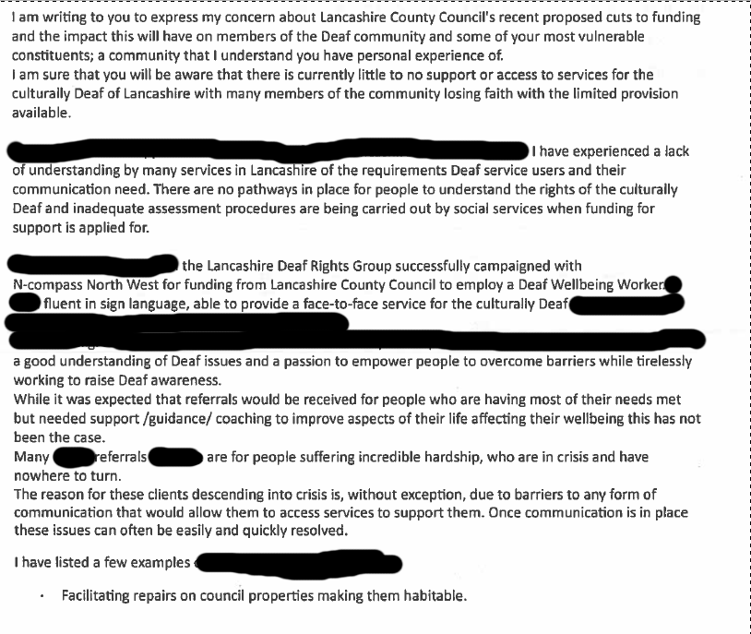
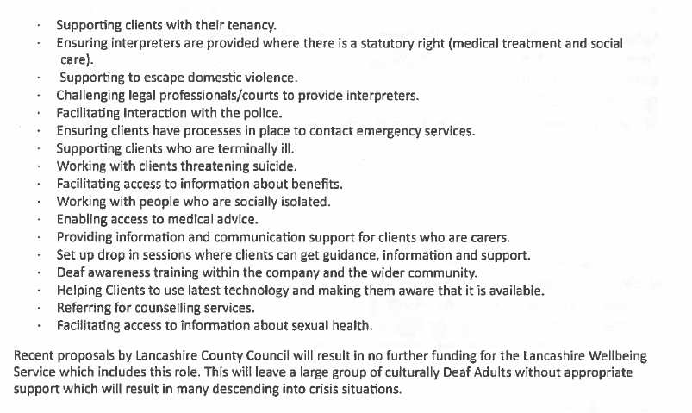
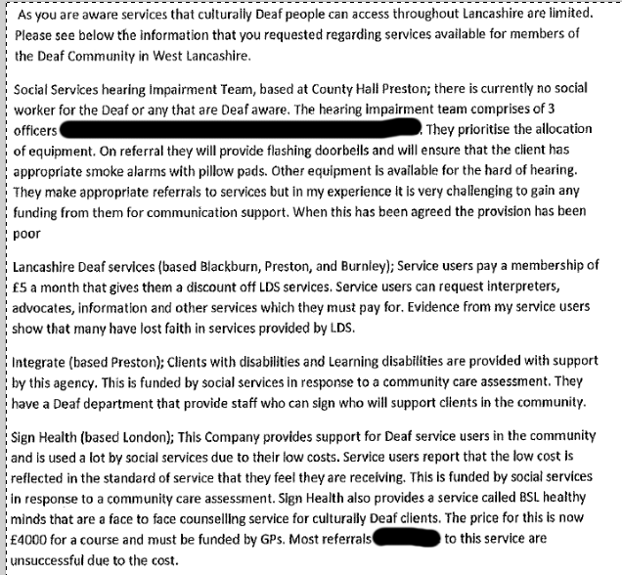
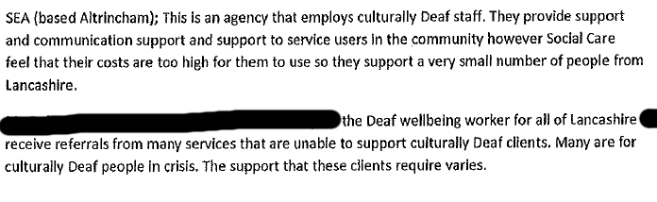
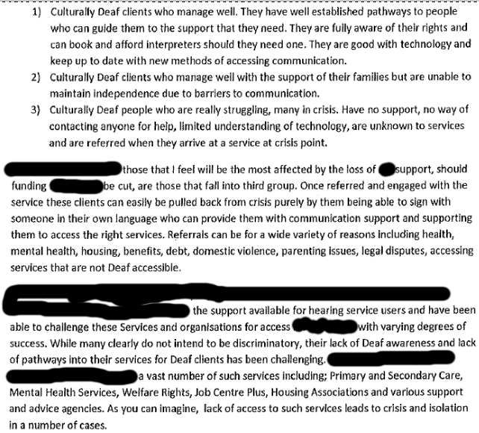
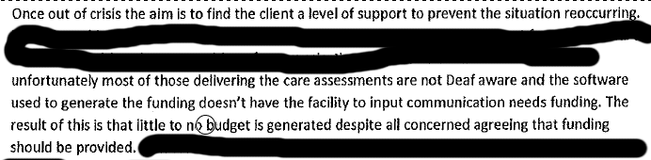

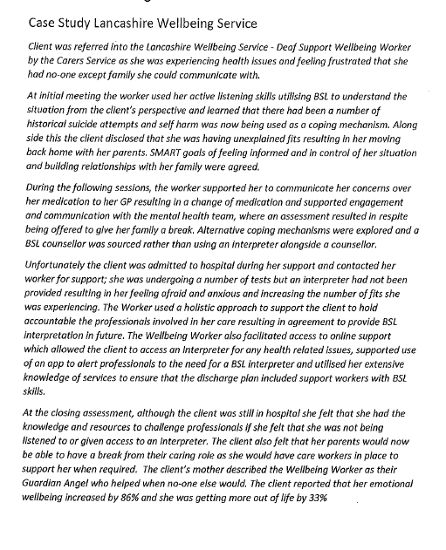

1.4 Responses from organisations
1.4.1 The current Lancashire Wellbeing Service consortium of providers

Impact of cutting the Lancashire Wellbeing Service on the Health and Social Care system

A consortium response

We understand the position Lancashire County Council is in with their budgets and also know that this situation is not of their making but has been driven by Government austerity measures.

However, our concerns as the current consortium of providers for this service, about the proposed cessation of this service are as follows:

- That this service if cut will cease on the 31st December 2019; nothing will replace it. How will the 11,000 vulnerable Lancastrians we support every year be supported?
- The mitigations highlighted in the December 2018 Cabinet report to deal with the risk of cutting this service are fundamentally flawed.
- That the cutting of this service is NOT a cost saving measure and will actually end up costing Lancashire County Council and other partners in the Health and Social Care system more money.
- That the authority is required to offer provide or arrange services aimed at reducing needs and helping people regain skills; so, it will be failing its statutory duties under the Care Act.

We have set out in more detail below under each of the above headings more detail to support our challenge, at the end of the report we have also included a selection of options that we would be keen to discuss with Lancashire County Council.

That this service if cut will cease on the 31st December 2019; with nothing to replace it.

Demand for Adult Social Care services is increasing in Lancashire. Over 70% of our annual 11,000 referrals come from statutory H&SC services.

The Lancashire Wellbeing Service (LWS) deflects people from Adult Social Care Police, Primary and Secondary Care, Job Centre Plus, Mental Health Teams, Ambulance Service, District Councils, Housing Providers, Police, Lancashire Fire and Rescue and the VCFS. Of those referred (11,000 pa) the reasons for referral are varied - Mild mental health problems 26%; Problems with family, finance, employment 12%; Social isolation, loneliness 26%; Struggling to cope, overwhelmed 24%; Healthier lifestyle needs 2%.

Removing Lancashire Wellbeing Service will inevitably compound the increasing demand in statutory care. Based on current figures, we are supporting approximately 3,000 referrals from Lancashire County Council Social Care annually. Removing the Lancashire Wellbeing Service, a key part of the preventative care system, will mean more people will go unsupported, or receive delayed support, resulting in an increased demand for more intensive, and expensive services from Lancashire County Council and from across the system.

Whilst we acknowledge the Lancashire Wellbeing Service has not reached the expected referral numbers agreed at the start of the contract, commissioners are fully aware that the type of demand is significantly different to what was anticipated. Low level physical and mental health need cohorts have been replaced by individuals with highly complex and often severe conditions and signposting has been replaced by coaching style interventions. This is not an underachievement, but an agreed and necessary shift in focus.

This type of work is more challenging and more time intensive and has been acknowledged in a recent Lancashire County Council report as a key part of the prevention pathway:

“The service is targeted to work with people who are at high or moderate risk of developing health and wellbeing issues, particularly those with low level mental health issues or long-term health conditions...to support people in building resilience, helping them to stay well and maintain independence and support them to maintain their wellbeing and reduce social isolation.”

Care, Support and Wellbeing of Adults in Lancashire – October 2018

The LWS has direct referral pathways that support many of Lancashire County Council's services and teams including;

- Children’s Social Care teams
- Falls Team
- Learning Disabilities and Autism Service
- Rapid Response
- Reablement
- Safeguarding
- Safeguarding, Inspection and Audit Service teams
- Substance Misuse Teams
- Children and Family Service
- Adult Community Team
- Customer Access Centre
- Discharge Team
- Duty team
- Community Emergency Response
Team

Additionally, we also support individuals to access benefits advice online utilising the Lancashire County Council recommended Gov.UK website. A method agreed with the commissioner of the Welfare Rights Service to deflect demand from them.

As well as supporting the most vulnerable in Lancashire the Lancashire Wellbeing Service provides critical support for the Deaf Community improving access to services for the individuals supported, many of whom have poor literacy skills. Lancashire Wellbeing Service has worked with 107 individuals over the last 12 months to October 2018. These individuals are struggling to access support and information from vital services in Lancashire including Social Care, Housing, Health, Finance and a high proportion are in crisis. Deaf Support Worker has supported access and highlighted issues with numerous teams and services across the County.

The demand will not cease if the service is cut – the only sensible assumption to make is that more people will reach crisis without this service being in place so will require a costlier intervention from Lancashire County Council and others.

That the cutting of this service is NOT a cost saving measure and will actually end up costing Lancashire County Council and other partners in the system more money

The savings earmarked in 2019/20 are in the region of £500k; in 2020/21 around £1.5m. The service costs £2.6m per annum so we presume the other £1.1m in year 2020/2021 not realised in savings, is being diverted into other cost centres in Lancashire County Council.

LCC Newton Review

The Newton’s Cost Benefit Analysis for this service cites a saving of £612,732 pa for Lancashire County Council, our observations are:

The review focussed on the impact of allocations avoided for the Safeguarding, Inspection and Audit Services team only and the avoidance of low packages of care; however, it does not quantify the benefit of Lancashire Wellbeing Service to Social Care through the below referral routes, where a much larger volume of people should apply to Newton’s workings;

• Referrals received from Safeguarding, Inspection and Audit Services teams – 265 pa
• Referrals from Customer Access Service (CAS) – 465 pa
• Referrals from Acute/community social care teams – 2129 pa
• Self-referrals from people into the service – 2011 pa

The cost benefit of this service to Lancashire County Council has been massively underrepresented.

Independent social return on investment study

An independent Social Return on Investment analysis shows that the Lancashire Wellbeing Service creates positive impacts not only for its service users but for their family members, and for associated partner services;

- For every £1 invested into this service £7 is generated in social value – so £2.6m invested per annum = £18.2m returned in social value pa
- Material outcomes for service providers and partners were reduced demand, increased resilience, improved physical health and community integration of service users.
- Material outcomes for service users were contentment, self-worth, a sense of purpose, hope and more volunteering.
- Average improvement for service users and their families was 25%
- Services users participated in volunteering on 12 occasions more per year
- 74% of services users would feel worse off in the absence of the service
- Reduced GP appointments by nearly 3 uses per person per year

The mitigations highlighted in the December 2018 Cabinet report to deal with the risk of cutting this service are fundamentally flawed

The Cabinet report cites utilisation of social prescribing and the wider Voluntary, Community and Faith Sector to offset Lancashire Wellbeing Service demand. The Lancashire Wellbeing Service supports people with moderate to severe mental and physical health needs (not low level as stated in the Cabinet paper) as our major service user cohort. The sector is ill equipped to provide that support, expecting them to do so would be counterproductive for the people who access our service. Lancashire Wellbeing Service works with Mental Health teams as a key partner and has received 889 referrals from this source over the last 12 months. In order to effectively support this cohort Wellbeing Workers, receive extensive training including; Health Trainer Level 3, Connect 5 and ASSIST (the Lancashire Wellbeing Service has responded to 146 disclosures of suicidal ideation on the contract to date). This level of expertise is not readily available in the Voluntary, Community and Faith Sector in Lancashire at the scale that would be required.

The report also cites Clinical Commissioning Groups funding similar services. These are small scale, focussed on navigation and connection of services, rather than resilience building through behaviour change, and are across a very limited geography. Removing the Lancashire Wellbeing Service will create an inconsistent offer across the county, a postcode lottery for preventative services.

Fylde and Wyre Clinical Commissioning Group fund one such service, our feedback in this area is that the impact is very limited. Below is note from a GP in Fylde who accesses the Lancashire Wellbeing Service.

“Just a note to say thank you for the work you do. It has made a significant difference to many of my patients socially and emotionally. I appreciate your can-do approach and not having to complete reams of paperwork for you unending help! In practical terms I think at the very least your interventions reduce our intervention saving time and cost and thereby it would not make sense for this service not to be perpetually funded.” - Fylde GP

The report also suggests mental health and primary care can offset demand. This is highly unlikely to happen as they themselves are extremely stretched. In fact, they utilise Lancashire Wellbeing Service as a resource themselves – over the last 12 months the Lancashire Wellbeing Service has received 1925 referrals from Clinical Commissioning Groups funded Health Services and 889 from the Mental Health teams. Without the Lancashire Wellbeing Service accepting these referrals, where would they receive help? Who would ensure their conditions don’t worsen, becoming a burden on Social Care?

The Lancashire Wellbeing Service has established extensive referral pathways across all sectors, it is a core part of the prevention and early intervention movement in Lancashire. Removing it sends the wrong message to the people of Lancashire; self-care, empowerment and personal resilience should come first. Suggesting primary care and mental health services can fill the void is a dangerous shift in the conversation between the public sector and citizens and doesn’t align with Lancashire County Council's own vision of “A shift to a different, more flexible approach that puts prevention, early intervention, and independence right at the heart of council and NHS services.”

That the authority is required to offer provide or arrange services aimed at reducing needs and helping people regain skills; so, it will be failing its statutory duties under the Care Act

In providing this services Lancashire County Council is not being too paternalistic but actually innovative and solution focussed in offering appropriate services linked to need in Lancashire.

In addition, it worth highlighting that the Care Act states that

- Local Authorities have a responsibility to ensure that people who live in their areas receive services that prevent their care needs from becoming more serious, or delay the impact of their needs

By terminating the Lancashire Wellbeing Service and not replacing it Lancashire County Council will be failing its statutory responsibility under the Care Act to provide or arrange services aimed at reducing needs and helping people regain skills.

In addition, the service is strengths based, empowering people to recognise and utilise their own personal and community assets therefore building resilience NOT reliance. In a health and social care system that is increasingly deficit focussed (despite all the rhetoric) the Lancashire Wellbeing Service builds confidence to self-care. Meaning that deflections would be far greater as service users utilise skills to avoid defaulting to needing support from Lancashire County Council in the long term.

This sentiment was highlighted in a recent Lancashire County Council presentation (Jan 19) delivered by Tony Pounder, Director of Adult Social Services titled Lancashire County Council's vision for care, support and wellbeing of adults in Lancashire & Budget Proposals for Adult Social Care and the public.

It stated that we need a profound system shift to;

- improve prevention
- avoid referrals and admissions
- manage in primary and community care settings

The Lancashire Wellbeing Service meets all of these points. Shouldn’t Lancashire County Council (the Health and Social Care system) be looking to build upon the Lancashire Wellbeing Service model recognising the important pathways it provides as a key county-wide prevention service, which is so well embedded, rather than remove it all-together?

Options that we would be keen to discuss with Lancashire County Council

We note from the Full Council papers (Feb 19) that should Cabinet ultimately not agree to any of these savings being implemented post consultation, then there would be sufficient reserves to support the budget until part way through 2022/23.

However, other options could include;
- Consider a redesign or reduced service rather than just cut it – we feel this is irresponsible and know that others share our concerns.
- Based on the number of referrals we take from each partners; consider approaching them to see if they would be willing to contribute a proportionate amount linked to the value they receive from the service. Has this been discussion at Integrated Care Plan level?
- NHS 10-year plan and other money that may flow through to Lancashire. There may be an opportunity to replace the current Better Care Funds with money (or some of it) through this route. But when will this money appear?
- Fund the proposed saving in 19/20 of @£500k so that the service runs till March 20 or seek the money from partners to see what the above bullet might bring, so there is some sort of continuity rather than cutting the service dead.
- Continue to fund the service until the contract ends – August 2020.

1.4.2 Burnley East Primary Care Network
We write on behalf of Burnley East Primary Care Network to express our disappointment about the proposed closure of the Lancashire Wellbeing Service. The Primary Care Network is the representative bodies for GPs in Burnley East. We see first-hand on a daily basis the benefits this service provides to our patients. Lancashire Wellbeing provides social and emotional support, practical help and guidance with finances, benefits, housing and a wide range of other issues which impact upon our patients mental and physical health. We have seen how the service benefits our patients in ways which we in the health service cannot. The closure of this service would have a significant detrimental impact upon the most vulnerable people in Burnley and we urge you to reconsider this decision.

1.4.3 Lancaster City Council
Thank you for the opportunity to comment on current consultations which have been considered by Lancaster City Council’s Council Business Committee at its meeting on Thursday 7th March 2019. To clarify, the Committee has considered seven consultations and is responding on behalf of the City Council regarding the following:
- Break Time
- Wellbeing Service
- Lancashire Waste and Recycling Service Centres
- Integrated Home Improvement Service
- Active Lives Healthy Weight, Health Improvement Service
- Drug and Alcohol Rehabilitation, Health Improvement Service
- Stop Smoking Services, Health Improvement Service

The Committee is pleased to hear that the County Council is holding consultation events for Officers, which will provide Officers with a valuable opportunity to submit in depth operational and technical comments.

Council Business Committee Members feel strongly that if the County Council was to cut these services/resources, the need for these services/resources would remain. It is therefore felt that the impact of cutting services might result in higher costs in future, as the need would not diminish and could, as a result, be shifted to other services. For example, if the Lancashire Break Time service were to cease entirely, this may have an impact on social work care and create a demand for more resources in that area. Members feel that for most of the services in the consultations, prevention is always considered better and more cost effective than cure.

Members have considered each consultation in turn however, with regard to the: Wellbeing Service; Active Lives Service, Drug/Alcohol Rehabilitation Service and Stop Smoking Service, there is an overwhelming concern for residents in the District that would be affected. Members feel that if these services were cut, there would be an increase in demand on social care work/resources, consequently creating a false economy for the County Council. There would also likely be cost implications for other services in the District such as GPs and associated health services. Members have suggested that some of these services combine to avoid them being cut all together. By having the same management/programme, some of the health services could potentially save money and provide a better all-round service for users in the District.

1.4.4 Lancashire Deaf Rights Group
We from the Lancashire Deaf Rights Group urge Lancashire County Council to think again about ending Lancashire Wellbeing Service at the end of this year. It is sad to hear it may come to this, letting clients down and they not knowing where to get help/support in future. We are concerned about deaf people whose only mean of communication is sign language.

We have attached an information letter and case reports. A worker under N Compass giving great support to deaf adults using her sign language skills. We hope you will read and get to understand vulnerable deaf people whose needs are different to those with hearing.

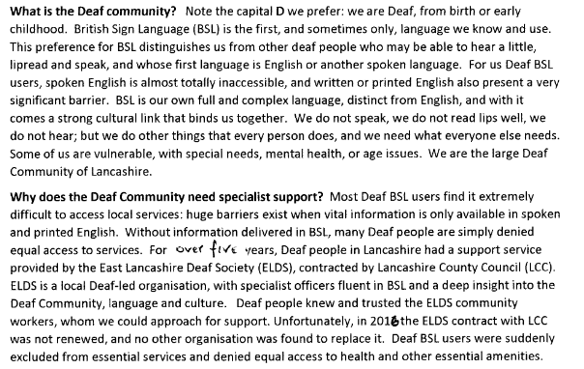

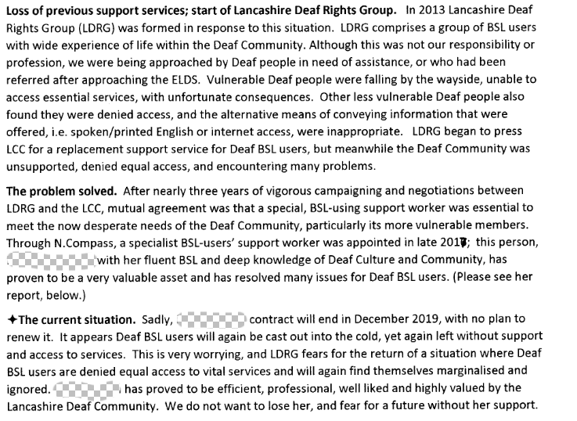
Case Study Lancashire Wellbeing Service
Client was referred into the Lancashire Wellbeing Service - Deaf Support Wellbeing Worker by the Carers Service as she was experiencing health issues and feeling frustrated that she had no-one except family she could communicate with.
At initial meeting the worker used her active listening skills utilising British Sign Language to understand the situation from the client’s perspective and learned that there had been a number of historical suicide attempts and self-harm was now being used as a coping mechanism. Alongside this the client disclosed that she was having unexplained fits resulting in her moving back home with her parents. SMART goals of feeling informed and in control of her situation and building relationships with her family were agreed.
During the following sessions, the worker supported her to communicate her concerns over her medication to her GP resulting in a change of medication and supported engagement and communication with the mental health team, where an assessment resulted in respite being offered to give her family a break. Alternative coping mechanisms were explored and a British Sign Language counsellor was sourced rather than using an interpreter alongside a counsellor.
Unfortunately the client was admitted to hospital during her support and contacted her worker for support; she was undergoing a number of tests but an interpreter had not been provided resulting in her feeling afraid and anxious and increasing the number of fits she was experiencing. The Worker used a holistic approach to support the client to hold accountable the professionals involved in her care resulting in agreement to provide BSL interpretation in future. The Wellbeing Worker also facilitated access to online support which allowed the client to access an Interpreter for any health related issues, supported use of an app to alert professionals to the need for a BSL interpreter and utilised her extensive knowledge of services to ensure that the discharge plan included support workers with British Sign Language skills.
At the closing assessment, although the client was still in hospital she felt that she had the knowledge and resources to challenge professionals if she felt that she was not being listened to or given access to an Interpreter. The client also felt that her parents would now be able to have a break from their caring role as she would have care workers in place to support her when required. The client’s mother described the Wellbeing Worker as their Guardian Angel who helped when no-one else would. The client reported that her emotional wellbeing increased by 86% and she was getting more out of life by 33%
Case Study Lancashire Wellbeing Service
Born with profound hearing loss and is reliant on lip reading. He struggles to fully understand conversations and has poor mental health. He owns a huge puppy who gives him his reason to live.
Having previously engaged with housing, health and social care services, has struggled to communicate with them, leaving him without medication and living in a single room of his dilapidated Council property while paying off an inappropriate historic tenant utility debt. At the time of him accessing the service he was very distressed but was encouraged to speak openly and at length. It was a priority to support X to access his GP for an urgent medication review and to contact the housing department of the council to report the condition.

When they eventually contacted them, they threatened to make him give up his dog, mistakenly thinking him to be a drug user and claiming they were unaware that he was deaf or that he had mental health issues. With support from our Deaf Support Wellbeing Worker he was able to communicate with them and their understanding and position changed accepting that his home was not fit for habitation and offering him a move to a new home. He declined this property and was then offered a second property with a garden for the dog that he accepted.
“Being able to refuse this first property actually went a long way towards making me feel more valued and listened to”.
With support he was able to access the Citizens Advice Bureau (CAB), Social Care and the Community Mental Health Team gaining assistance to move and health support for both himself and X. He was able to resolve the utility debt issues and to pursue a refund of his over-payment. X’s life has changed significantly, he now feels empowered, understands his rights, is calmer and in better mental health and pain free. He feels supported, more confident and knows how to get help when he needs it. His home conditions are much improved, suitable for him and X and in good repair. Without the threat of eviction he feels safe and secure, he is more organised and in control of his life and is better able to manage his anxiety and mental health. The organisations and businesses involved understand their errors and have taken steps to prevent this happening again. He recorded a 34% improvement in his Health and Wellbeing assessment score and a 20% improvement in his Get the Most out of Life score and reported;
“Words can’t express the gratitude I feel, I now have choices I feel I’m back in control of my life. It’s a new start for both me and X and we’re looking forward to the future”
Feedback received during November 2018

"X is very grateful to the service and does not know how they would manage without it."

"Enjoyed the visit and happy with the outcome"

Feedback received during December 2018

"Great support!!"

"Just wanted to say it was lovely to meet you yesterday and thank you very much for your contribution to the meeting, it was extremely helpful and I am hopeful we can improve NS access to effective communication, the deaf culture and improve his quality of life. It was great to hear your passion and if I work with anyone from the deaf community again I will know where to come for advice."

1.4.5 The Better Care Fund Steering Group

Health and Well Being Service and Home Improvement Service Consultations
The Better Care Fund Steering Group welcomes the opportunity to respond to the above consultations and we would like to thank Clare Platt for attending our meeting to explain the consultations and to Tony Pounder for his assistance at that meeting as well.

Some of the Clinical Commissioning Group representatives also had a further opportunity to discuss the intentions around these consultations at a meeting again led by Clare on 11th March. We have drawn on some of that information and discussions as well to inform this response.

We note that both of these services are currently funded via the Better Care Fund and whilst we understand the funding pressures the Local Authority is under we would have expected a decision to take these to consultation to have been agreed with Partners at the group. It is disappointing that this did not happen and we would now expect the decision making process to include the Better Care Fund Steering Group. The Health and Wellbeing Board has committed to integration and for this to be truly effective we need to be open and transparent in our financial oversight and collective endeavour.

Lancashire Health and Well-Being Service

We understand that the current service is a targeted service which offers support to adults with a range of social and health issues who are at high or moderate risk of a crisis situation developing. The service is provided across the county on a locality basis via voluntary sector providers. The services are set up slightly differently in each area to reflect the situation. We understand in the service cost is £2.6 million and the Local Authority’s consultation is to cease the service but retain £600k which will be used to fund mitigations for social care of the impact of removing the service.

We have received some information directly from the services setting out the usage by locality and by referral source. The table sets out a summary of that data.
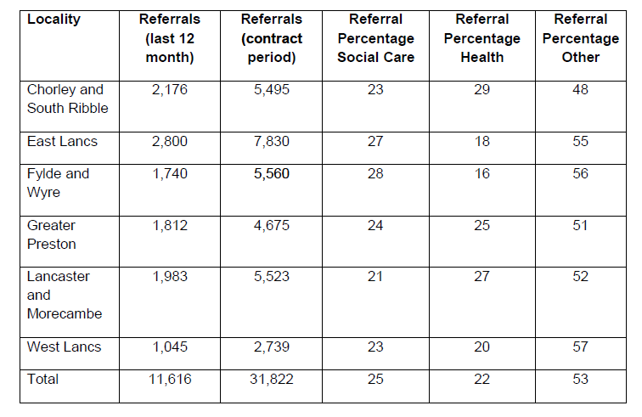
1) We are aware that our neighbourhoods and other services in all areas value this service for supporting people who have been identified as having the needs set out above and report significant improvements in their well-being as a result, reducing the impact on statutory services as a result. Whilst we cannot assume that all of the people who benefit from this service would ultimately end in statutory services, if half the number did this would result in an extra 5,500 contacts and subsequent work which would place a significant burden on social care as well as other partners.

2) Whilst 25% of the referrals are from social care it is not at all clear that only this 25% would have a social care need. Many of the referrals from health and other services are also likely to have a social care need, even though the referral was from elsewhere; if the service is reduced to only taking social care referrals within the reduce sum this is likely to result in a significant rise in workload for social care to manage the initial contact, as referrals will be routed via that route and subsequently may swamp the service.

3) Whilst we have received referral information we do not have details on the utilisation of the service in area to say whether the service in each area is well utilised or not; we would be interested to understand this further.

4) We understand that in some areas similar services are commissioned by Clinical Commissioning Groups, but we also understand considerable work has been undertaken to ensure these services do not duplicate. This is a concern to those commissioners where the removal of these services will now cause a gap that could perhaps have been avoided.

Our recent discussions at the Better Care Fund Steering Group have been regarding the need to increase prevention and early support though integration and reducing this service would seem to be going against this strategy.

Summary

In summary the issues we would like to be considered are set out below:

Lancashire Health and Wellbeing Service:

How the burden of support required to those who have not reached crisis will be provided to prevent an impact on statutory services?

The utilisation of current services so that we understand the impact removal will have by area and how this might be mitigated by working together?

The Better Care Fund Steering Group currently reports to the Health and Wellbeing Board on both of these services under the Joint Governance Structures set up to support the Better Care Fund. As such the Group wants to understand the outputs of the consultations, work with the Local Authority to help address its needs and most importantly the needs of the population of Lancashire, but also undertake its governance role.

We would like to see the detail of the impact assessments undertaken by the Local Authority with regard to both of these consultations to assist in the discussions on mitigation.

We would happy to discuss any of this further at the Better Care Fund Steering Group.

1.4.6 Morecambe Bay Integrated Care Partnership

Morecambe Bay Integrated Care Partnership welcomes the opportunity to respond to the consultations that Lancashire County Council is running. We had an opportunity to talk briefly about these with Louise Taylor and Sakthi Karunanithi on 21st February 2019 at our System Leadership Team meeting. At that meeting we agreed with Sakthi that once the consultations were complete he would we present the outcomes pertinent to the Lancashire North area and we would discuss ways we might manage the outcomes as possible.

Some of the Clinical Commissioning Group representatives also had a further opportunity to discuss the intentions around these consultations at a meeting led by Clare Platt on 11th March. We have drawn on some of that information and discussions as well to inform this response.

We have set out below response to a number of the consultations.

- Lancashire Health and Wellbeing Service

We understand that the current service is a targeted service which offers support to adults with a range of social and health issues who are at high or moderate risk of a crisis situation developing. The service is provided across the county on a locality basis via voluntary sector providers. The services are set up slightly differently in each area to reflect the local neighbourhood development and we know that in Lancashire North the service works very closely with the Integrated Care Communities we have all developed as part of our Better Care Together Strategy.

We understand the service cost is £2.6 million across the County and the Local Authority’s consultation is to reduce this to £600k. We would like to point out at this stage that the predecessor to the service was part funded by the North Lancashire Primary Care Trust. When a decision was made by the Council to re-tender the service the Primary Care Trust offered to continue to fund its element but this was declined at the time.

We have received some information directly from the services setting out the usage by locality and by referral source. The usage in Lancashire North is as follows:
- Referrals in the last 12 months – 1,983
- Referrals during the full life of the Service – 5,523

Of these referrals the source is:
- 21% Social Care
- 27% Health
- 52% other

We are aware that our Integrated Care Communities and other services value this service for supporting people who have been identified as having the health and social needs outlined above and report significant improvements in their well-being as a result, reducing the impact on statutory services as a result.

Whilst 21% of the referrals are from social care it is not at all clear that only this 21% would have a social care need, particularly as a number of referrals will come via the multi-disciplinary team meetings which are now set up in each of our Integrated Care Communities (ICCs) to review the needs of people whose cases are presented by health and social care colleagues alike.

Removal of this source of support will place pressure back with those professionals who seek alternative support. If the service is reduced to only taking social care referrals within the reduced sum this is likely to result in a significant rise in workload for social care to manage the initial contact, as referrals will be routed via that route and subsequently may swamp the service.

Whilst we have received referral information we do not have details on the utilisation of the service in our area to say whether the service is well utilised or not; we would be interested to understand this further.

Our recent discussions at the launch event to refresh our system strategy Better Care Together, held on 26th February, which had a number of local authority attendees, included a significant desire to increase prevention and early support though integration and reducing this service would seem to be going against this strategy.

The proposal therefore to cease the Lancashire Wellbeing Service will have a significant impact on the development of local neighbourhoods and is counter to our systems current strategy of building on our Integrated Care Communities (ICCs) to facilitate health and care delivery closer to home. The NHS Long Term Plan provides an opportunity to explore options for local collaborative working to bring services together as part of the creation of Primary Care Networks, and we would welcome the opportunity to explore further.

Summary

At the meeting on the 11th March we discussed the need for discussion at each Borough level to understand the local impact and how this might be managed if at all possible – a topic we also agreed at the Morecambe Bay Leadership Team with Louise and Sakthi. We would look to include their neighbourhoods in this discussion with a view to enabling each neighbourhood to understand the impacts, but also generate a discussion on how all of the services covered by the wider consultations and other provision could be viewed more holistically in the future on that footprint.

We look forward to this discussion being arranged.

    - University Hospitals of Morecambe Bay NHS Foundation Trust

This letter provides feedback from the University Hospitals of Morecambe Bay NHS Foundation Trust (UHMB) to the Lancashire County Council (LCC) Savings Options for 2019/20.

The financial challenges facing Lancashire County Council are recognised and as with the health sector, change in service delivery is required to ensure that Lancashire County Council can remain within allocated budgets. As a system partner, University Hospitals of Morecambe Bay NHS Foundation Trust is committed to working with Lancashire County Council to achieve financial balance. However, there are concerns with the current savings proposals for 2019/20 and beyond and that impact assessments carried out to date have been limited to impact on Lancashire County Council and has not been cognisant of the impact on the wider health and social care system.

We would welcome a more detailed approach to impact assessment that includes consideration of the impact of proposed changes on the wider health and care system. This would include an opportunity to collaborate on the development of cost improvement schemes within overall health and care investments and to identify improved mechanisms for system approaches to addressing budgetary pressures whilst maintaining sustainability of health and care services.

Detailed below are some specific areas of feedback on the current proposals:

SC610 Lancashire Wellbeing Service – the proposal to cease the Lancashire Wellbeing Service will have a significant impact on the development of local neighbourhoods and is counter to the current strategy of building on our Integrated Care Communities (ICCs) to facilitate health and care delivery closer to home. The NHS Long Term Plan provides an opportunity to explore options for local collaborative working to bring services together as part of the creation of Primary Care Networks.

1.5 Response from the Police and Crime Commissioner for Lancashire
I would like to thank you for the opportunity to comment on Lancashire County Council’s budget proposals.

I recognise the significant funding issues the County Council faces in 2019/20 and future years and understand that you face some very difficult decisions as you determine the services you will provide to the people of Lancashire. I continue to seek savings in my own budget and would therefore request that we engage in a collaborative dialogue in respect of the services that we have some cross-over in responsibility to examine the opportunities that exist to drive out value for money.

I am concerned that the level of savings you are required to make will have enormous consequences not just for the citizens of Lancashire but will of course impact upon the resources of the Constabulary as the service of first and last resort. It is inevitable that as the support you are able to provide the more vulnerable members of our communities is reduced due to the drastic cuts to your funding there will inevitably be an increase in the numbers of people suffering crisis which will, in turn, require support from the policing service.

I am keen to ensure that wherever possible we work together to ensure we can provide services in the most efficient way possible and seek to engage together in areas such as mental health, community safety partnerships and child protection services and suggest that we continue to seek opportunities for collaboration in the delivery of services in such areas.

I would also like to suggest that we look to work together in other areas where we might achieve increased value for money such as the use of property and assets and the provision of support services as improved efficiency in these areas can free up much needed resource to our respective front line services.

I would like to highlight a specific savings proposal included in the consultation document, the SC610 - Lancashire Wellbeing Service.

The saving proposal is to cease the provision of the Wellbeing Service and the paper recognises that there will be a direct impact on other services both within Lancashire County Council and for external organisations. I can confirm that Lancashire Volunteer Partnership (LVP), in which both of our organisations take significant roles, forecasts a significant increase in demand placed directly upon it as a result of this proposal. This in itself is a cause for concern as the most vulnerable people that use the Wellbeing service may be left without support if Lancashire Volunteer Partnership doesn't have the capacity to support them.

The saving proposal also recognises that there will be an increase in demand for social care services at Lancashire County Council for a number of people that would have previously been diverted from social care through the work of the Wellbeing service. The saving proposal indicates that this demand could generate additional social care cost at a level as much as £650,000 per annum.

Discussions with colleagues at Lancashire Volunteer Partnership have suggested that investment of considerably less than £650,000 per year could provide a service to meet a significant amount of the demand arising from the closure of the Wellbeing Service and divert individuals from social care.

They suggest 1 Supervisor and 9 Volunteer Officers to cover the entire County and supplement what Lancashire Volunteer Partnership already deliver. The cost of this would be in the region of £350k. It is estimated that each Volunteer Officer could carry a caseload of 30 referrals at any one time which would likely result in 60 per annum, this would see overall the opportunity to fulfil a further 540 referrals per year.

This opportunity would need further development and discussion between Lancashire County Council and Lancashire Volunteer Partnership colleagues to determine if it could deliver a similar (or possibly greater) financial saving whilst ensuring a better outcomes than would be the case if the saving is developed as proposed.

I welcome your view on the opportunity that may exist in this instance and your consideration of taking an alternative approach in the replacement of the Wellbeing Service.

I am aware that the specific design of a number of the budget options you have identified is on-going and I would ask that you would engage with myself, my office and the Constabulary at every opportunity where our services have impact or cross over to allow us to contribute fully to the design of new services in the future.

I look forward to having the opportunity to comment further as the options you identify move forward and that together we can work towards the provision of quality services to the people of Lancashire.

Ritchie, J. and Spencer, L. (1994) Qualitative Data Analysis for Applied Policy Research. In: Bryman, A. and Burgess, B., Eds., Analyzing Qualitative Data, Routledge, London.

